OCR OUTPUT

# Page : 1

Hisense

Installation

&

Maintenance

Manual

VRF AIR-CONDITIONER

(HEAT PUMP)

OUTDOOR UNIT

- Outdoor Units -

MODEL

AVW-36H3FH

AVW-48H3FH

AVW-60H3FH

IMPORTANT:

READ AND UNDERSTAND

THIS MANUAL BEFORE

USING THIS HEAT-PUMP

M00376Q

AIR CONDITIONER.

KEEP THE MANUAL FOR

ORIGINAL INSTRUCTIONS

FUTURE REFERENCE

NEWPAGE----------NEWPAGE

# Page : 3

**IMPORTANT NOTICE**

O Hisense pursues a policy of continuing improvement in design and performance of products. The right is, therefore, reserved to vary specifications without notice.

O Hisense cannot anticipate every possible circumstance that might involve a potential hazard.

O This heat pump air conditioner is designed for standard air conditioning only. Do not use this heat pump air conditioner for other purposes such as drying clothes, refrigerating foods, or for any other cooling or heating process.

O The installer and system specialist shall secure safety against leakage according to local regulations or standards. The following standards may be applicable if local regulations are not available.

O No part of this manual may be reproduced without written permission.

O Signal words (DANGER, WARNING, and CAUTION) are used to identify levels of hazard seriousness. Definitions for identifying hazard levels are provided below with their respective signal words.

* **DANGER**: Immediate hazards which WILL result in severe personal injury or death.
* **WARNING**: Hazards or unsafe practices which COULD result in severe personal injury or death.
* **CAUTION**: Hazards or unsafe practices which COULD result in minor personal injury or product or property damage.
* **NOTE**: Useful information for operation and/or maintenance.

O It is assumed that this heat pump air conditioner will be operated and serviced by English-speaking people. If this is not the case, the distributor should add safety, caution, and operating signs in the native language.

O If you have any questions, contact your distributor or dealer of Hisense.

O This manual gives a common description and information for this heat pump air conditioner which you operate as well as for other models.

O Install these air conditioners by local regulations or standards.

O This heat pump air conditioner has been designed for the following temperatures. Operate the heat pump air conditioner within this range:

**Temperature**

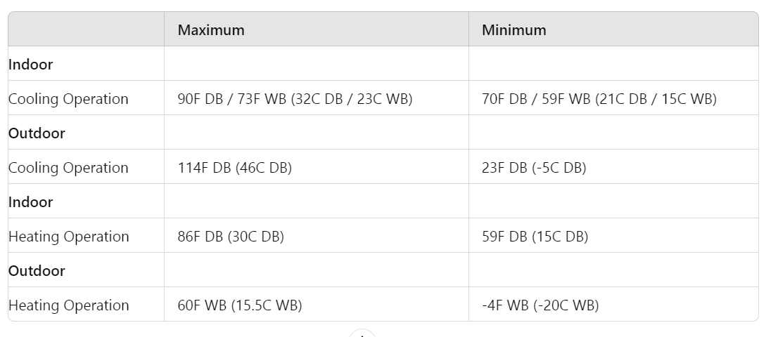

DB: Dry Bulb, WB: Wet Bulb

O The air-conditioning installation and maintenance can only be conducted by dealers or professionals.

**NOTE:** These air conditioners are only applicable for cooling or heating mode. Do not operate in cool and heat mode difference in temperature for changing operate mode.

This manual should be considered a permanent part of the air conditioning equipment and should remain with the air conditioning equipment.

NEWPAGE----------NEWPAGE

# Page : 4

**SAFETY SUMMARY**

**DANGER**

* Do not introduce flammable and poisonous gases into the refrigerant cycle when performing tests.
* Do not pour water into the indoor or outdoor unit. These products are equipped with electrical parts. If poured, it will cause a serious electrical shock.
* Do not touch or adjust safety devices inside the indoor or outdoor units. If these devices are touched or readjusted, it may cause a serious accident.
* Do not open the service cover or access panel for the indoor or outdoor units without turning OFF the main power supply.
* Refrigerant leakage can cause difficulty with breathing due to insufficient air. Turn OFF the main switch, extinguish any naked flames and contact your service contractor if refrigerant leakage occurs.
* The installer and system specialist shall secure safety against refrigerant leakage according to local regulations or standards.
* Use an ELB (Electric Leakage Breaker). In the event of a fault, there is danger of an electric shock or a fire if it is not used.
* Do not install the outdoor unit where there is a high level of oil mist, flammable gases, salty air, or harmful gases such as sulfur.

**WARNING**

* Do not use any sprays such as insecticide, lacquer, hair spray, or other flammable gases within approximately 3.3 ft. (1 meter) from the system.
* If the circuit breaker or fuse is often activated, stop the system and contact your service contractor.
* Do not perform installation work, refrigerant piping work, drain piping, and electrical wiring connection without referring to our installation manual. If the instructions are not followed, it may result in water leakage, electric shock, or fire.
* Check that the ground wire is securely connected. If the unit is not correctly grounded, it can lead to electric shock. Do not connect the ground wiring to gas piping, water piping, lightning conductor, or ground wiring for the telephone.
* Connect a fuse of specified capacity.
* Do not put any foreign material on or inside the unit.
* Make sure that the outdoor unit is not covered with snow or ice before operation.
* Before performing any brazing work, check to ensure that there is no flammable material around.
* When using refrigerant, be sure to wear leather gloves to prevent cold injuries.
* Protect the wires, electrical parts, etc., from rats or other small animals. If not protected, rats may gnaw at unprotected parts, which may lead to a fire.
* Fix the cables securely. External forces on the terminals could lead to a fire.
* If the supply cord is damaged, it must be replaced by the manufacturer, its service agent, or similarly qualified persons to avoid a hazard.
* This appliance can be used by children aged 8 years and above and persons with reduced physical, sensory, or mental capabilities or lack of experience and knowledge if they have been given supervision or instruction concerning use of the appliance in a safe way and understand the hazards involved. Children shall not play with the appliance. Cleaning and user maintenance shall not be made by children without supervision.
* The appliances are not intended to be operated by means of an external timer or separate remote-control system.

NEWPAGE----------NEWPAGE

# Page : 5

**SAFETY SUMMARY**

**WARNING**

* The appliance is not to be used by children or persons with reduced physical, sensory, or mental capabilities, or lack of experience and knowledge, unless they have been given supervision or instruction concerning the use of the appliance by a person responsible for their safety.
* Children should be supervised to ensure that they do not play with the appliance. Keep the appliance and its cord out of reach of children under 8 years.

**CAUTION**

* Do not install the indoor unit, outdoor unit, remote control switch, and cable within approximately 10 ft. (3 meters) from strong electromagnetic wave radiators such as medical equipment.
* Supply electrical power to the system to energize the oil heater for 12 hours before start-up after a long shutdown.
* Do not step or put any material on the product.
* Provide a strong and correct foundation so that:
  + a. The outdoor unit is not on an incline.
  + b. Abnormal sound does not occur.
  + c. The outdoor unit will not fall down due to a strong wind or earthquake.

**NOTE:**

* It is recommended that the room be ventilated every 3 to 4 hours.
* The heating capacity of the heat pump unit is decreased according to the outdoor air temperature. Therefore, it is recommended that auxiliary heating equipment be used in the field when the unit is installed in a low-temperature region.
* Operate the heat pump air conditioner within this range.
* Regarding installation altitude below 3281 ft. (1000 m);
* Regarding transport/storage temperature within -13131F (-2555 C);
* This appliance is intended to be used by expert or trained users in shops, in light industry, and on farms, or for commercial use by laypersons.
* The A-weighted emission sound pressure level at workstations does not exceed 70 dB(A).

**CHECKING PRODUCT RECEIVED**

* Upon receiving this product, inspect it for any shipping damage.
* Claims for damage, either apparent or concealed, should be filed immediately with the shipping company.
* Check the model number, electrical characteristics (power supply, voltage, and frequency), and accessories to determine if they are correct.
* The standard utilization of the unit shall be explained in these instructions.
* Please contact your local agent as the occasion arises.
* HISENSE's liability shall not cover defects arising from the alteration performed by a customer without HISENSE's consent in written form.

NEWPAGE----------NEWPAGE

# Page : 7

**TABLE OF CONTENTS**

1. Safety Summary
2. Structure

2.1 Outdoor Unit & Refrigerant Cycle

2.2 Necessary Tools and Instrument List for Installation ......................... 3

1. Transportation and Handling

3.1 Transportation

3.2 Handling of Outdoor Unit ........................................................... 4

1. Outdoor Unit Installation ............................................................ 5

4.1 Factory-Supplied Accessories ................................................ 5

4.2 Initial Check ......................................................................... 5

4.3 Service Space ..................................................................... 6

4.4 Installation Work ................................................................. 6

1. Refrigerant Piping Work .......................................................... 8

5.1 Piping Materials ................................................................. 8

5.2 Refrigerant Piping Work ................................................... 8

5.3 Branch Pipe ....................................................................... 11

5.4 Piping Connection ............................................................ 12

5.5 Air Tightness Test ............................................................ 13

5.6 Vacuum Pumping and Charging Refrigerant ............... 14

5.7 Caution of the Pressure by Check Joint ....................... 16

5.8 Additional Refrigerant Charge ....................................... 17

5.9 Collecting Refrigerant ...................................................... 19

1. Electrical Wiring .................................................................... 19

6.1 General Check ................................................................... 19

6.2 Electrical Wiring Connection ........................................... 20

1. Outdoor Unit Dip-Switch Setting ........................................ 24
2. Test Run .................................................................................... 25
3. Safety and Control Device Setting ..................................... 30

NEWPAGE----------NEWPAGE

# Page : 8

**1. Safety Summary**

**WARNING**

* Do not perform installation work, refrigerant piping work, drain piping, and electrical wiring connection without referring to the installation manual.
* Check that the ground wire is securely connected.
* Connect a fuse of specified capacity.

**CAUTION**

* Do not install the indoor unit, outdoor unit, remote control switch, and cable within approximately 10 ft. (3 meters) from strong electromagnetic wave radiators such as medical equipment.

**2. Structure**

**2.1 Outdoor Unit & Refrigerant Cycle**

*Outdoor Unit-AVW-36/48/60H3FH*

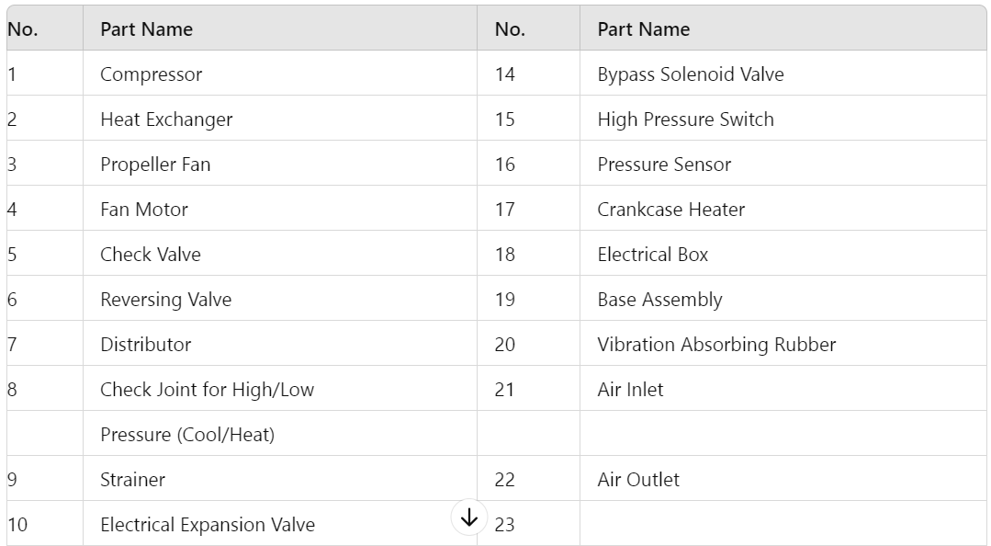

NEWPAGE----------NEWPAGE

# Page : 9

**Refrigerant Cycle**

*Outdoor Unit-AVW-36/48/60H3FH*

*Note: Refrigerant Flow Direction (Cooling Operation), Refrigerant Flow Direction (Heating Operation), Field Refrigerant Piping, and Flare Connection.*

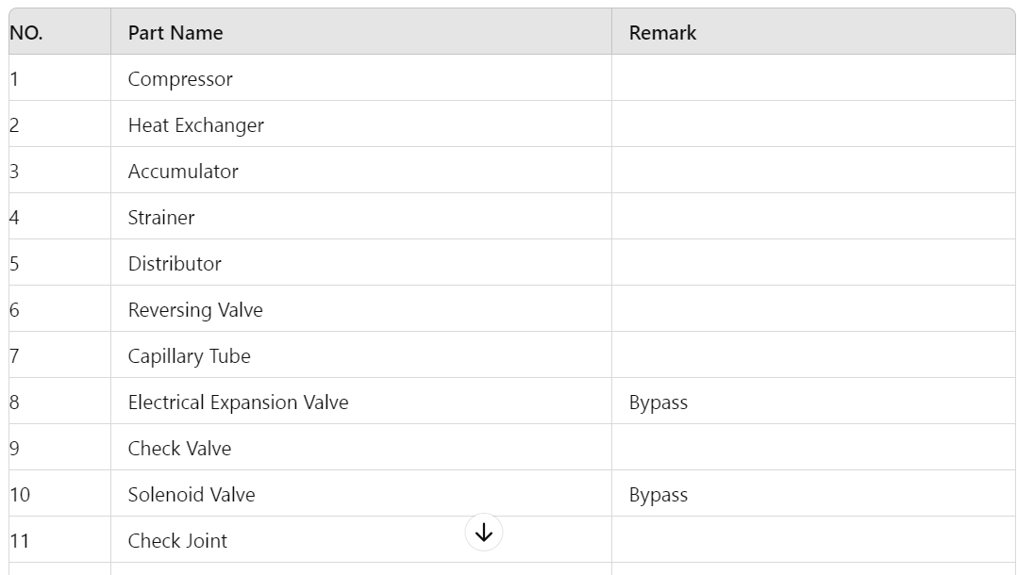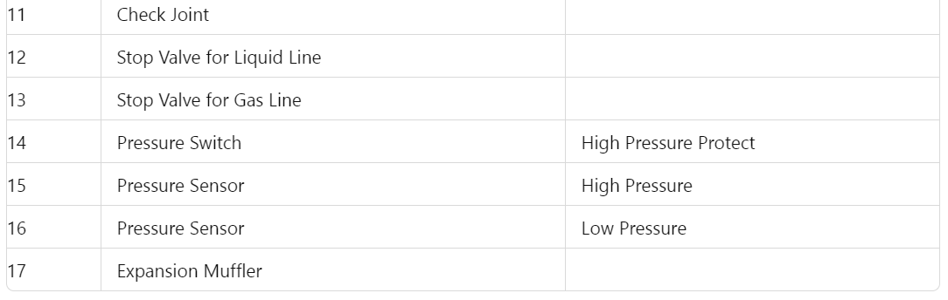

NEWPAGE----------NEWPAGE

# Page : 10

2.2 Necessary Tools and Instrument List for Installation

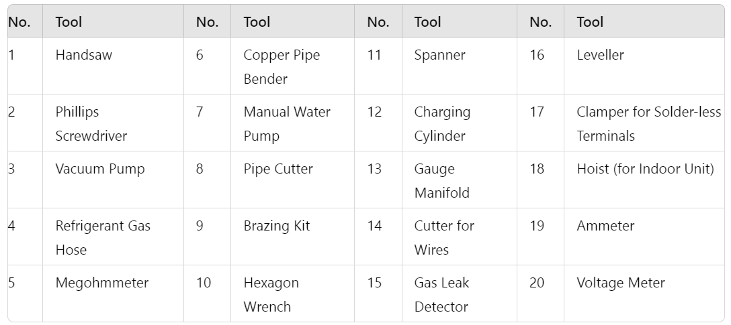

Use tools and measuring instruments exclusive for the new refrigerant in case of direct contact with refrigerant.

* Interchangeability is available with current R22
* O: Only for Refrigerant R410A (No Interchangeability with R22)
* X: Prohibited
* +: Only for Refrigerant R407C (No Interchangeability with R22)

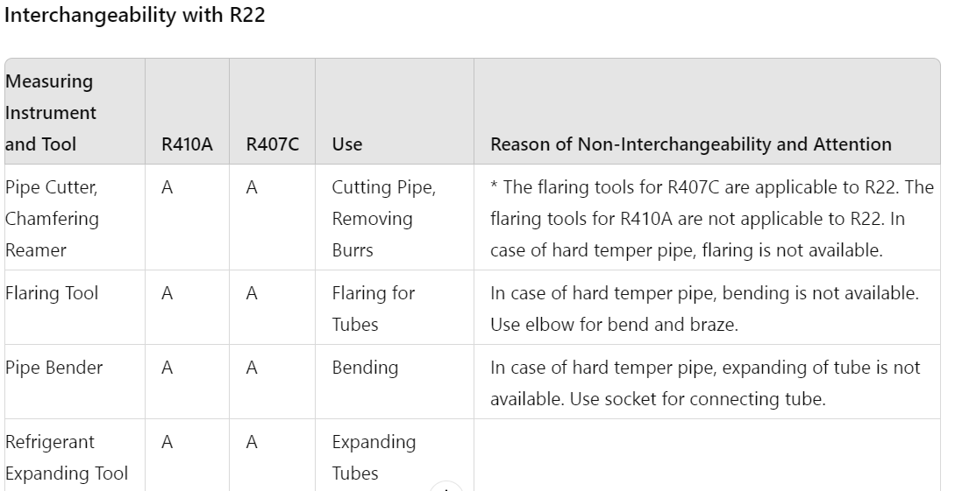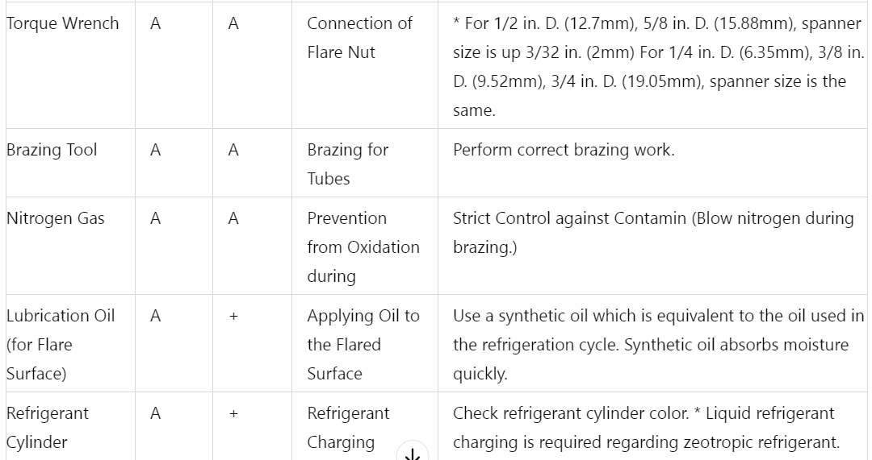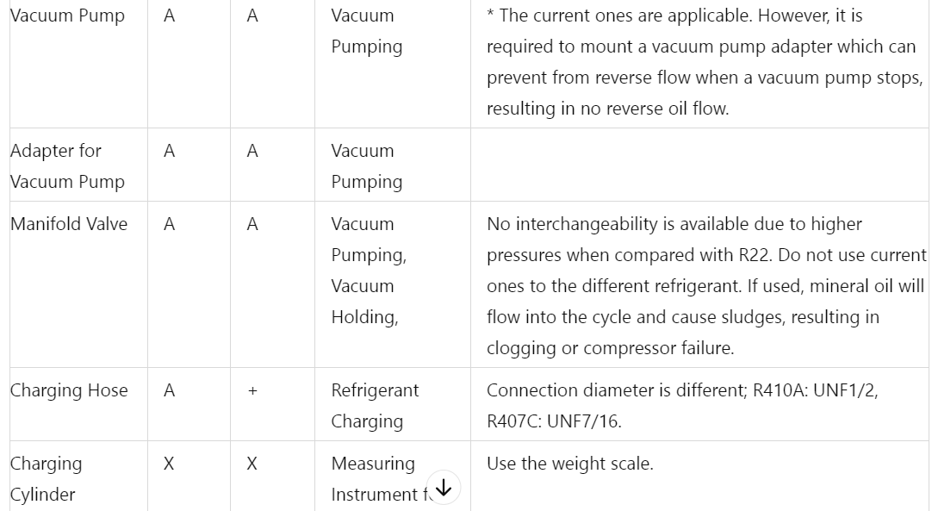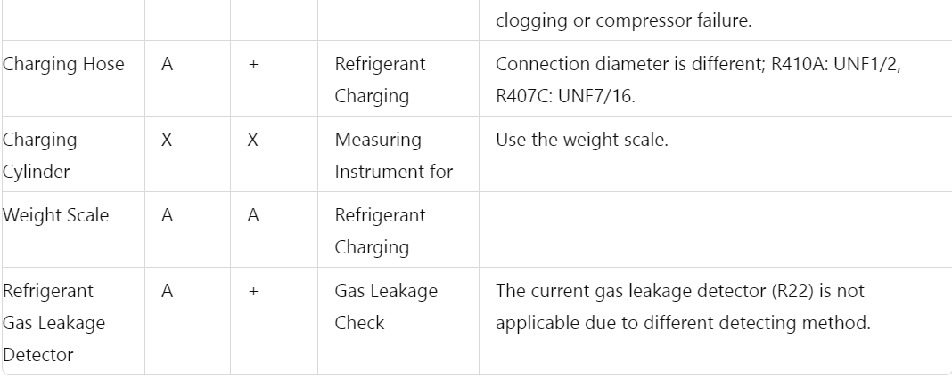

Note: Interchangeability with R407C.

NEWPAGE----------NEWPAGE

# 

# 

# Page : 11

3. Transportation and Handling

3.1 Transportation

**!WARNING**

* Transport the product as close to the installation location as possible before unpacking.

**!CAUTION**

* Do not put any material on the product.
* Apply two lifting wires onto the outdoor unit when lifting it by crane.

**Hanging Method**

* When hanging the unit, ensure a balance of the unit, check safety and lift up smoothly.
  1. Do not remove any packing materials.
  2. Hang the unit under packing condition with two (2) ropes, as shown in Fig. 3.1.

Do not remove the plastic band or the corrugated paper frame. Pass the wire ropes through each lifting hole in the wooden base as shown.

3.2 Handling of Outdoor Unit

**!WARNING**

* Do not put any foreign material into the outdoor unit and check to ensure that none exists in the outdoor unit before the installation and test run. Otherwise, a fire or failure, etc. may occur.

**When Using Handles**

* When manually lifting the unit using the handles, pay attention to the following points:
  1. Do not remove the wooden base from the outdoor unit.
  2. To prevent the unit from overturning, pay attention to the center of gravity as shown in the below figure.
  3. Two or more personnel should be used to move the unit.

**!CAUTION**

* If there is no package to move, please protect with cloth or paper.

NEWPAGE----------NEWPAGE

# Page : 12

4. Outdoor Unit Installation

4.1 Factory-Supplied Accessories

Check to ensure that the following accessories are packed with the outdoor unit.

**Table 4.1 Factory-Supplied Accessories**

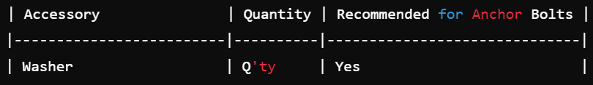

**Note:**

* Install near the wall to avoid facing the wind directly. Ensure that the service space should be secured.
* If any of these accessories are not packed with the unit, please contact your contractor.

4.2 Initial Check

* Install the outdoor unit where good ventilation is available and where it is dry.
* Install the outdoor unit where the sound or the discharge air does not affect neighbors or surrounding vegetation. The operating sound at the rear or sides may be higher than catalog values at the front.
* Check that the foundation is flat, level, and sufficiently strong (space: 23-5/8 in. or 600 mm).
* Do not install the outdoor unit where there is a high level of oil mist, salty air, or harmful gases such as sulphur.

**Note:**

* If extremely strong wind blows directly against the air discharge portion, the fan may rotate reversely and be damaged.
* Do not install the outdoor unit where electromagnetic waves directly radiate to the electrical box. Install it at least 10 ft. (3 meters) away from electromagnetic wave radiators.
* When installing in snow-covered areas, mount field-supplied hoods at the discharge side and inlet side of the heat exchanger.
* Install the outdoor unit in shade or where it is not exposed to direct sunshine or high-temperature heat sources.
* Avoid installing where dust or other contamination could block the outdoor heat exchanger.
* Install in a space with limited access to the general public.
* Do not install where a seasonal wind directly blows onto the outdoor heat exchanger or where wind from a building space directly blows onto the outdoor fan.

**!CAUTION**

* Aluminum fins have very sharp edges. Pay attention to avoid injury.

**Note:**

* Install the outdoor unit on a roof or in an area where only service engineers can access.

NEWPAGE----------NEWPAGE

# Page : 13

4.3 Service Space

Install the outdoor unit with a sufficient space around it for operation and maintenance as shown below (Fig. 4.1).

* **Single Installation**
  + Upper Side is Open: Keep a distance of 3-15/16 in. (100mm) on the right side of the unit.
* **Multiple Installation**
  + Left, Right & Upper Sides are Open: Keep a distance of 3-15/16 in. (100mm) on right side of unit.

**Fig. 4.1 Installation Space Requirement**

4.4 Installation Work

1. Secure the outdoor unit with the anchor bolts.  
   **Fig. 4.2 Installation of Anchor Bolts**
2. When installing the outdoor unit, fix the unit by anchor bolts. Refer to Fig. 4.3.  
   **Fig. 4.3 Position of Anchor Bolts**
3. Example of fixing outdoor unit by anchor bolts.  
   **Fig. 4.4 Fixing Example**
4. Fix the outdoor unit firmly so that declining, making noise, and falling down by strong wind or earthquake is avoided.
5. When installing the unit on a roof or a veranda, drain water sometimes turns to ice on a cold morning. Therefore, avoid draining in an area people often use because it is slippery.

**Fig. 4.5 Additional Fixing Arrangement**

NEWPAGE----------NEWPAGE

# Page : 14

4.5 Drain Piping Installation

1. In case drain piping is necessary for the outdoor unit, use the drain-kit.
   * Recommended Metal Plate Size (Field-Supplied):
     + Material: Hot-Rolled Mild Steel Plate (SPHC).
     + Plate Thickness: 4.5T.
2. **Fig. 4.6 Frame and Base Installation**

4.6 Foundation Installation

1. The whole base of the outdoor unit should be installed on a foundation. When using vibration-proof mat, it should also be positioned the same way.  
   When installing the outdoor unit on a field-supplied frame, use metal plates to adjust the frame width for stable installation as shown in Fig. 4.6.
   * **Incorrect**: Base Width of Outdoor Unit: 2-31/32 in. (Outdoor Unit is Unstable).
   * **Correct**: Base Width of Outdoor Unit: 2-31/32 in. (Outdoor Unit is Stable).
2. **Fig. 4.6 Frame and Base Installation (Continued)**

NEWPAGE----------NEWPAGE

# Page : 15

**5. Refrigerant Piping Work**

**5.1 Piping Materials**

1. Prepare locally-supplied copper pipes.
2. Select the piping size from Table 5.1.  
   **Table 5.1 Piping Size**

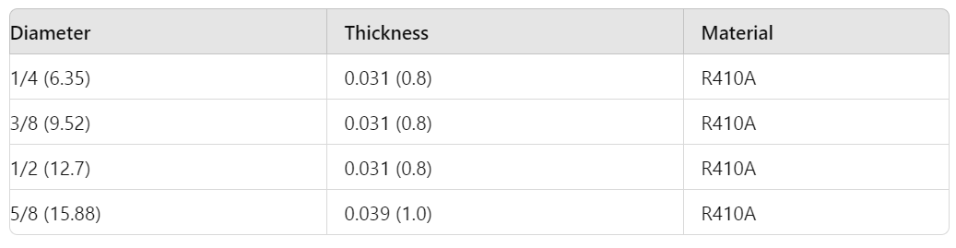

3. Select clean copper pipes. Ensure there is no dust and moisture inside the pipes. Blow the inside of the pipes with nitrogen or dry air to remove any dust or foreign materials before connecting pipes.

**Flare Nut Dimension**

Use the flare nut as below:

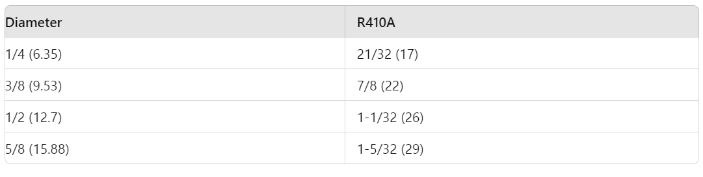

**5.2 Refrigerant Piping Work**

1. Ensure that the directions for refrigerant piping work according to the tables.  
   **Table 5.2 Limitation of Outdoor Unit**

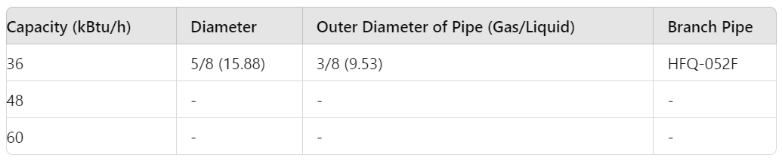

**Table 5.3 Indoor Unit Pipe Model**

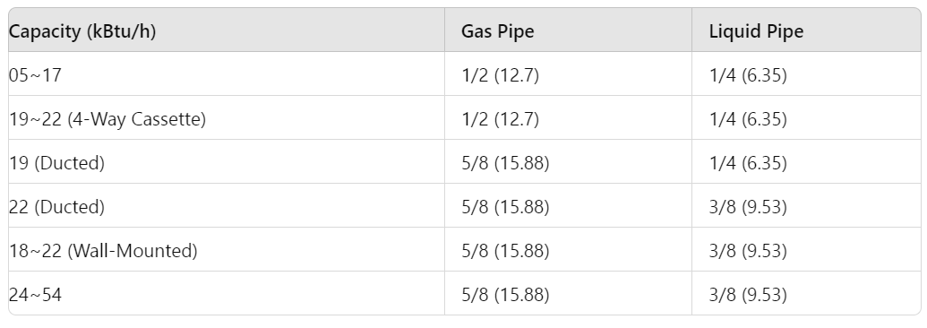

# NEWPAGE----------NEWPAGE

# 

# Page : 16

**Combination between Indoor Unit and Outdoor Unit**

**Table 5.4 Indoor Unit Type List**

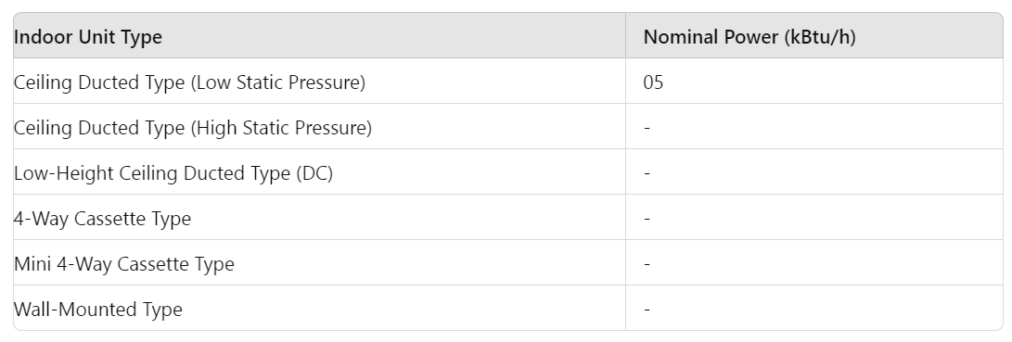

Table 5.5 Limitation of Combination Quantity

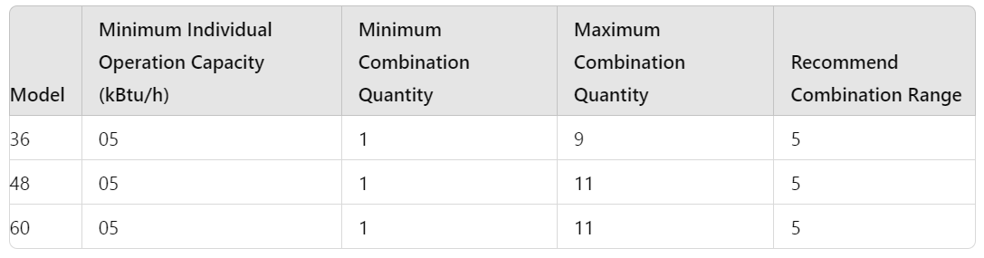

* (*1) The connection ratio should not be bigger than 100% for systems where all indoor units may operate at the same time; otherwise, overload operation may occur in harsh conditions or narrow range.
* (*2) Capacity ratio must be 100% when only one indoor unit is connected, and the refrigerant additional charge should be reduced according to the indoor unit type. Refer to Table 5.10.
* (*3) The capacity of indoor unit should be modified when the capacity ratio exceeds 100% or the combination quantity exceeds the recommended quantity.
  + Modified capacity = nominal capacity x correction factor

**Correction factors are defined as follows:**

* **Indoor Unit Type:** Wall mounted
  + **Model:** 07/09
  + **Correction Factor:** 2.0

NEWPAGE----------NEWPAGE

# Page : 17

**Table 5.6 Refrigerant Pipe System**

**System Example:** This is a system of one outdoor unit and six indoor units. Pipe materials are not provided by the manufacturer.

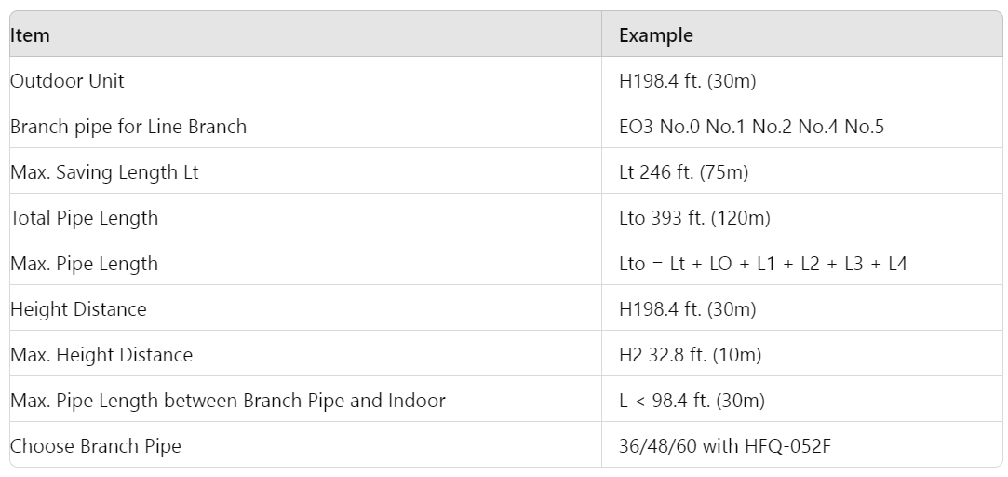

Oil Trap is recommended at every 32.8 ft. (10 meters) lift.

# NEWPAGE----------NEWPAGE

# Page : 18

Table 5.7 T Shape Branch Pipe

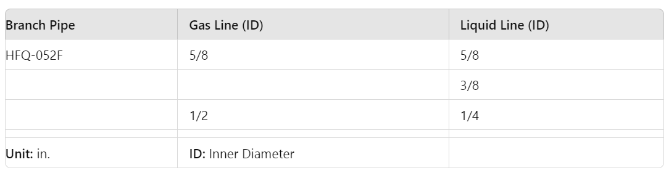

# NEWPAGE----------NEWPAGE

# Page : 19

**5.4 Piping Connection**

Pipes can be connected from 4 directions as shown in Fig. 5.1.

* **Rear Side Piping Work**
  + Piping Cover (Knock-Out Hole)
  + Service Cover (Knock-Out Hole)
* **Right Side Piping Work**
  + Piping Cover (Knock-Out Hole)
* **Front Side Piping Work**
  + Piping Cover (Knock-Out Hole)
* **Bottom Side Piping Work**
  + Piping Work (Knock-Out Hole)

**Fig. 5.1 Piping Direction**

**Table 5.8 Tightening Torque for Flare Nut**

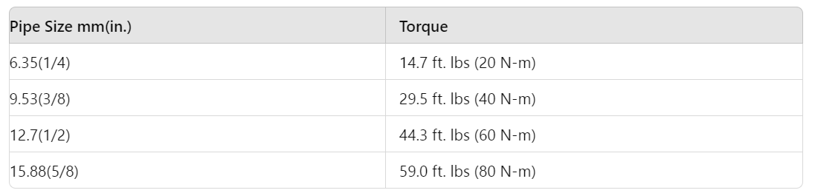

**Notes and Instructions:**

* Pipes can be connected from 4 directions as shown in Fig. 5.1. Make a knock-out hole in the front pipe cover or bottom base to pass through the hole.
* After removing the pipe cover from the unit, punch out the holes following the guideline with a screwdriver and a hammer.
* Attach insulation (Field-Supplied) for cables and pipes protection.

**Fig. 5.2 Remove Service Cover**

1. Confirm that the valve is closed.
2. Prepare a field-supplied bend pipe for the liquid line. Connect it to the liquid valve by flare nut through the square hole of the bottom base.
3. For Gas Piping Connection:
   * Prepare a field-supplied bend pipe for the gas line. Braze it and the factory-supplied pipe flange at the outside of the unit.
   * Do not apply double spanner work here to avoid refrigerant leakage.

NEWPAGE----------NEWPAGE

# Page : 20

**(b) Bottom Side Piping Work**

1. Apply the oil thinly at the seat surface of the flare nut and pipe before tightening.
2. When tightening the flare nut, use two spanners.
3. Refrigerant Oil is field-supplied.

**Model: a68HES-H (Ether Oil)  
Manufacturer: IDEMITSU KOSAN Co., Ltd.**

**Procedure**

* Completion
* Applying Check of Nitrogen Pressure
* Repairing of Leakage Part

**Bottom Side Piping Hole**

* Bottom Base

**(c) Rear Piping Work**

* Rear Cover
* Rear Piping Guide Hole

**Stop Valve Core for Opening and Closing**

**Fig. 5.3 Stop Valve Position**

Operation of the stop valve should be performed according to the figure below:

* **Stop Valve:**
  + Do not apply two spanners at this position. If applied, leakage will occur.
  + Tighten the cap with a clockwise motion to close and counterclockwise to open. (Attach this after work)
  + Torque: Liquid Valve - 12 ft. lbs (16 N-m), Gas Valve - 36 ft. lbs (49 N-m)

**Rubber Sheath (Field-Supplied)**

* To avoid damage, protect cables and pipes with rubber sheath.
* Cut a "+" shape gap at rubber sheath center, wire lead rubber sheath.

**5.5 Air-Tightness Test**

1. The stop valve has been closed before shipment; however, make sure that the stop valves are closed completely.
2. Connect the indoor unit and the outdoor unit with field-supplied refrigerant piping.
   * Suspend the refrigerant piping at certain points and prevent it from touching weak parts of the building such as walls or ceilings.
   * If touched, abnormal sound may occur due to the vibration of the piping. Pay special attention in case of short piping length.

**Refrigerant Piping**

* Hexagonal Wrench Size: 5/32 (4mm)
* To open or close the spindle valve:
  + Spindle Valve Torque: Gas - 8.911.1 ft lbs (1215 N-m), Liquid - 3.75.9 ft lbs (57 N-m)

# NEWPAGE----------NEWPAGE

# 

# Page : 21

**Gas Valve**

O Tighten nut cap below torque, great torque will bring on refrigerant leakage of valve spindle.

**Cap**

Hexagonal Wrench  
(to open/close spindle valve)

Tighten the cap with a torque 21.7 ft.-Ibs (29.4 N-m).

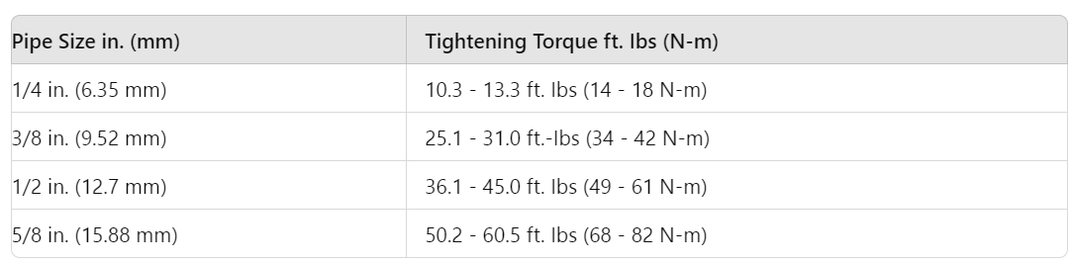

**Spindle Valve**

Counterclockwise ---- Open  
Clockwise ---- Close  
(Closed before Shipment)

O Make air-tightness test after valve spindle is turned off closely.

**O Ring**(Rubber)

**Note:**

Do not connect nut cap on test joint, which is used for connecting refrigerant charging hose. It is normal that a slight leak sound comes out when the seal cap of the check joint and the valve spindle cap are opened.

**Check joint**

(Only charging hose can be connected)

Tighten the cap with a torque 6.6 ft.-Ibs

**Hexagonal Wrench Size in. (mm)**

Gas: 7/32 (5)  
Liquid: 5/32 (4)

**Vacuum Pumping and Charge Refrigerant**

(1) Connect a manifold gauge to the check joints at both sides. Continue vacuum pumping work until the pressure reaches 756 mmHg or lower for one to two hours. After vacuum pumping work, stop the manifold valve's valve, stop the vacuum pump and leave it for one hour. Check to ensure that the pressure in the manifold gauge does not increase.

**Note:**

1. This unit is only for the refrigerant R410A. The manifold gauge and the charging hose should be for exclusive use for R410A.
2. If vacuum degree of -14.5 psi (-0.1 MPa/756 mmHg) is not available, it is considered a gas leakage or entering moisture. Check for any gas leakage once again and correct. If no leakage exists, operate the vacuum pump for more than one to two hours.

(2) Connect the gauge manifold using charging hoses with a nitrogen cylinder to the check joints of the liquid line and the gas line stop valves. Perform the air-tightness test. Do not open the stop valves. Apply nitrogen gas pressure of 601 psi (4.15 MPa).

(3) Check for any gas leakage at the flare nut connections or brazed parts by gas leak detector or foaming agent.

(4) After the air tightness test, release nitrogen gas.

**Caution:**

* After pipe and nut cap connected, when making air tightness test, open the stop valve spindle cap, make sure valve closed already (clockwise).

**Refrigerant Piping**

(5) Connect adjusted valve and charge kettle to check joint of liquid valve.

(6) Fully open the gas valve and liquid valve slowly.

(7) Open adjusted valve to add refrigerant (must be refrigerant is liquid).

(8) Operate cool mode, charge stated refrigerant.

(9) Confirm the capacity of charging refrigerant with balance. An excess or a shortage of refrigerant is a cause of damage to the units.

(10) Fully open the liquid valve.

NEWPAGE----------NEWPAGE

# Page : 22

**Never use the refrigerant charged in the outdoor unit for air purging. Insufficient refrigerant will lead to failure.**

**Thermal Insulation Finishing Work**

* Wrap tape around the thermal insulation of gas pipe and liquid pipe.

**Indoor Unit**

* Cover the flare nut and union of the piping connection with thermal insulation.
* Insulate the liquid pipe to prevent capacity decrease due to ambient air conditions and low pressure.

**Gas Line  
Liquid Line**

* Cover the liquid line with thermal insulation.
* Check to ensure that there is no gas leakage. When a large amount of refrigerant leaks, the following troubles may occur:
  1. Oxygen Deficiency
  2. Generation of Harmful Gas Due to Chemical Reaction with Fire

**Gas Line Stop Valve**

**Liquid Line Stop Valve**

**Nitrogen Tank for Air Tight Test  
Manifold Gauge during Brazing  
Vacuum Pump**

**Caution:**

* At the test run, fully open the spindle. If not fully opened, the devices will be damaged.
* An excess or shortage of refrigerant is the main cause of damages to the units. Charge the correct refrigerant quantity according to the description on the label inside the service cover.
* Check for refrigerant leakage in detail. If a large refrigerant leakage occurs, it will cause difficulty with breathing or harmful gases would occur if a fire was being used in the room.

**Note:**

Special Attention Regarding Refrigerant Gas Leakage

Pay attention to the critical gas concentration to avoid accidental refrigerant gas leakage before installing air conditioning systems.

R: Total Quantity of Charged Refrigerant (Ibs(kg))  
C: Critical Concentration 0.026 Ibs/ft³ (0.42 kg/m³)  
V: Room Volume (ft³(m³))

*This value should be decided according to each country's regulation such as ISO5149, EN378, and ASHRAE Standard 15. In the case that the calculated critical concentration is higher than this value, take the following actions:*

1. Provide a gas leakage detector and exhaust fan controlled by its gas leakage detector.
2. Provide effective opening in the wall or door for ventilation to the next room so that the critical gas concentration can be maintained lower than the above value. (Provide an opening with an area greater than 0.15% of the floor surface at the lower part of a door.)

# NEWPAGE----------NEWPAGE

# Page : 23

**CAUTION**

1. **Maximum Permissible Concentration of HFC GAS R410A**The refrigerant R410A is an incombustible and non-toxic gas. However, if leakage occurs and gas fills a room, it may cause suffocation. Once leakage occurs, it is a must to take effective actions to make the concentration of R410A lower than 0.026 Ibs/ft³ (0.42 kg/m³).
2. **Calculation of Refrigerant Concentration**
   1. Calculate the total quantity of refrigerant R (Ibs(kg)) charged in the system connecting all the indoor units of target rooms.
   2. Calculate the volume of the room installing this unit V (ft³(m³)).
   3. Calculate the refrigerant concentration C (Ibs/ft³) (kg/m³) of the room according to the above equation. Please follow local codes or regulations, if any.

**Caution of the Pressure by Check Joint**

When the pressure is measured, use the check joint of gas stop valve (A in the figure below) and use the check joint of liquid piping (B in the figure below). At that time, connect the pressure gauge according to the following table because the high pressure side and low pressure side changes by operation mode.

**Caution of the Pressure by Check Joint**

When the pressure is measured, use the check joint of gas stop valve (A in the figure below) and use the check joint of liquid piping (B in the figure below). At that time, connect the pressure gauge according to the following table because the high pressure side and low pressure side changes by operation mode.

**Caution of the Pressure by Check Joint**

When the pressure is measured, use the check joint of gas stop valve (A in the figure below) and use the check joint of liquid piping (B in the figure below). At that time, connect the pressure gauge according to the following table because the high pressure side and low pressure side changes by operation mode.

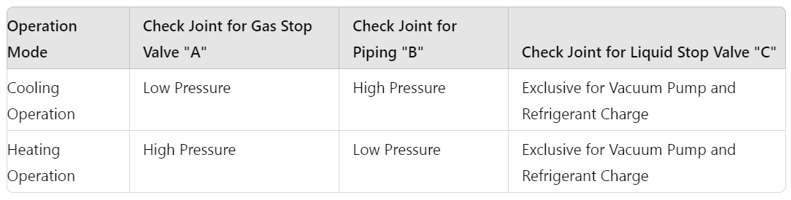

**NOTE:**

Be careful that refrigerant and oil do not splash onto the electrical parts when removing the charge hoses.

Fig 5.4 Check Joint Position

NEWPAGE----------NEWPAGE

# Page : 24

**5.8 Additional Refrigerant Charge**

It is necessary to add additional refrigerant charge as follows:

**Additional Refrigerant Charge Calculation**

Although refrigerant has been charged into this unit, it is required that additional refrigerant be charged according to piping length.

A. Determine an additional refrigerant quantity according to the following procedure, and charge it into the system.  
B. Record the additional refrigerant quantity to facilitate service activities thereafter.

**1. Calculating Method of Additional Refrigerant Charge**

**Example for Model AVW-60H3FH:**

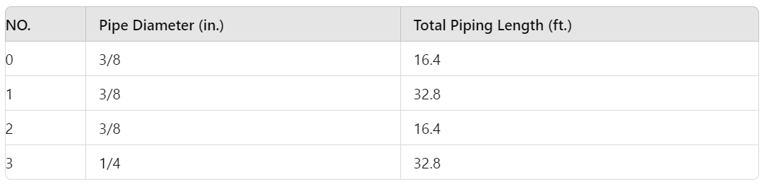

See example for Model AVW-60H3FH, and fill in the following table:

Pipe Diameter (in./mm) | Total Piping Length (ft./m) | Additional Charge (Ibs)

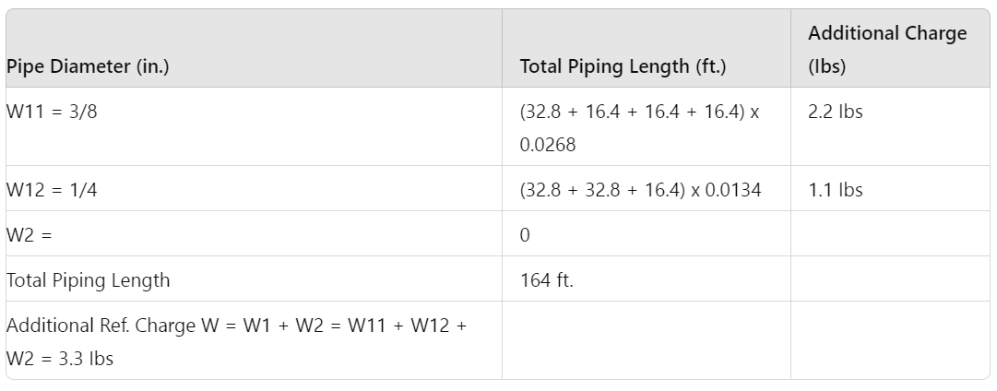

Additional Refrigerant Charge according to Table 5.9:

Table 5.9 Additional Refrigerant Charge Calculation

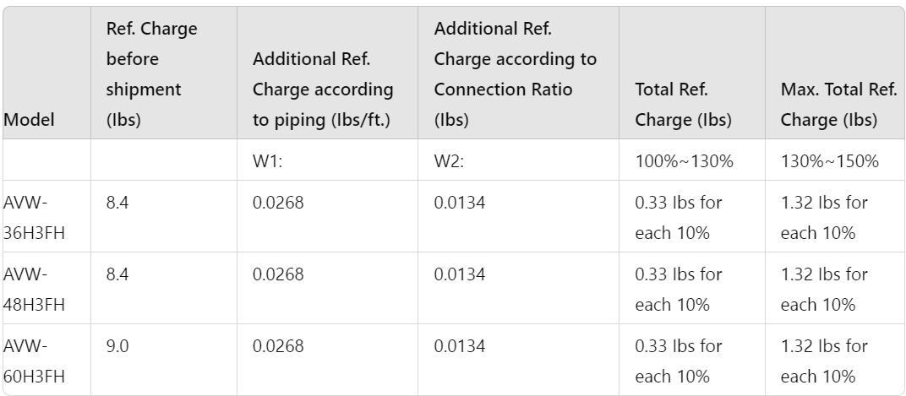

**Note:** Less than 10% is calculated as 10%.

NEWPAGE----------NEWPAGE

# Page : 25

**2. Charging Work**

Charge refrigerant (R410A) into the system as follows:

1. **For charging refrigerant**:
   * Connect the gauge manifold using charging hoses with a refrigerant cylinder to the check joint of the liquid line stop valve.
   * Fully open the gas line stop valve and slightly open the liquid line stop valve. Charge refrigerant by opening the gauge manifold valve.
   * Charge the required refrigerant by operating the system in cooling. Ensure to charge the correct volume by utilizing a weight scale. An excess or shortage of refrigerant is the main cause of trouble to the units.
   * Fully open the liquid line stop valve after completing refrigerant charge.
2. **Record of Additional Charge**:
   * Total Additional Charge W: ____ Ibs
   * Record the refrigerant charging quantity in order to facilitate maintenance and servicing activities.
   * Total refrigerant charge of this system is calculated in the following formula:  
     **Total Ref. Charge of This System = W0 + W1 + W2**
   * Total Ref. Charge of This System: ____ Ibs
   * Date of Ref. Charge Work: ____ Day ____ Month ____ Year
3. **Dip-Switch Setting for Piping Length**:  
   Follow below setting for the Dip-Switch for piping length:
   * DSW6 (Mark Show Switch Key Position):
     + Shipment: ____
     + I.U. is located higher than O.U. (65.6 ft. / 20m): ON
     + I.U. is located higher than O.U. (82.0 ft. / 25m): ON
4. **Notice of Additional Charge**:  
   When the system is connected one-to-one, the connection ratio must be 100%, and the additional refrigerant needs to be reduced as per the following requirements:

Table 5.10 Reduced Refrigerant Charge for Special Indoor Units

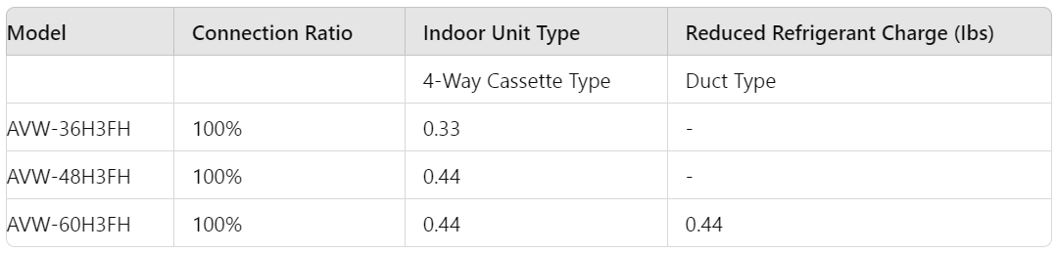

# NEWPAGE----------NEWPAGE

# Page : 26

**5.9 Collecting Refrigerant**

When the refrigerant should be collected into the outdoor unit due to indoor/outdoor unit relocation, collect the refrigerant as follows:

1. Attach the manifold gauge to the gas stop valve and the liquid stop valve.
2. Turn ON the power source.
3. Set the DSW1-1 pin of the outdoor unit PCB at the "ON" side for cooling operation. Close the liquid stop valve and collect the refrigerant.
4. When the pressure at the lower pressure side (gas stop valve) indicates -1.45 psi (-0.01 MPa, 684 mmHg), perform the following procedures immediately:
   * Close the gas stop valve.
   * Set the DSW1-1 pin at the "OFF" side (To stop the unit operation).
5. Turn OFF the power source.

**Electrical Wiring**

**WARNING**

* Turn OFF the main power switch to the indoor unit and the outdoor unit and wait for more than 10 minutes before electrical wiring work or a periodical check is performed.
* Check to ensure that the indoor fan and the outdoor fan have stopped before electrical wiring work or a periodical check is performed.
* Protect the wires, electrical parts, etc., from rats or other small animals. If not protected, rats may gnaw at unprotected parts, and at worst, a fire will occur.
* Avoid the wirings from touching the refrigerant pipes, plate edges, and electrical parts inside the unit. If not done, the wires will be damaged, and at worst, a fire will occur.

**CAUTION**

* Tightly secure the power source wiring using the cord clamp inside the unit.

**NOTE**

* Fix the rubber bushes with adhesive when conduit tubes to the outdoor unit are not used.

**6.1 General Check**

1. Make sure that the field-selected electrical components (main power switches, circuit breakers, wires, conduit connectors, and wire terminals) have been properly selected according to the electrical data. Ensure that the components comply with the National Electrical Code (NEC).
2. Check to ensure that the voltage of the power supply is within 10% of the nominal voltage. If not, electrical parts will be damaged.
3. Check to ensure that the capacity of the power supply is enough. If not, the compressor will not be able to operate due to abnormal voltage drop at starting.
4. Check to ensure that the earth wire is connected.
5. Check to ensure that the electrical resistance is more than 1 megohm by measuring the resistance between the ground and the terminal of the electrical parts. If not, do not operate the system until the electrical leakage is found and repaired.

**CAUTION**

* Measure the low pressure by the pressure gauge and keep it from decreasing below -1.45 psi (-0.01 MPa). If the pressure is lower than -1.45 psi (-0.01 MPa), the compressor may be faulty.

NEWPAGE----------NEWPAGE

# 

# Page : 27

**6.2 Electrical Wiring Connection**

1. **Connect the power supply wires to the terminal board** in the electrical control box of both the outdoor unit and indoor unit. Connect the earth wire to the electrical control box of the outdoor unit. Additionally, connect the earth wire to the earth screw in the electrical control box of the indoor unit. Refer to Fig. 6.2.
2. **Connect the wires between the outdoor and indoor units** to terminals 1 and 2 on the terminal board.
   * If the power supply wiring is connected to terminals 1 and 2 of the terminal board (TB1), the printed circuit board will be damaged.
   * Refer to Fig. 6.1 for correct and incorrect wiring positions.

**Correct Wiring Position:**

**Fig. 6.1 Indoor unit and outdoor unit communication wire connection***Do not connect the power source line to terminals 1 and 2. These terminals are for control. If connected, the printed circuit board will be damaged.*

1. **Do not wire in front of the fixing screw** of the service panel. If you do, the screw cannot be removed.
2. **Use shielded twisted pair for communication wire** connecting the indoor unit and outdoor unit, respectively connected to the 1 and 2 terminals of the terminal block between the indoor and outdoor unit. Connect the communication wire of the wired controller to the A and B terminals of the indoor unit terminal block.

**NOTES:**

1. In case the total wiring length at intermediate wiring between the outdoor unit and indoor unit, and between indoor units is less than 328 ft. (100m), it is possible to use normal wiring (more than AWG18 (0.75mm²)) except for twist pair cable.
2. The wiring can be extended up to 1640.4 ft. (500m). If the total wiring length is less than 98.4 ft. (30m), it is possible to use normal wiring AWG22 (0.3mm²) except for twist pair cable.

NEWPAGE----------NEWPAGE

# Page : 29

**NOTE:**

1. **Supply the power source of outdoor units and indoor units respectively.**
   * Power source wiring is fundamental according to this method.
   * Install an ELB (Earth Leakage Breaker) in the power source. If ELB is not used, it may cause electric shock or fire at worst.
   * The tightening torque of each screw shall be as follows:
     + M4: 0.7 to 1.0 ft-lbs (1.0 to 1.3 N-m)
     + M5: 1.5 to 1.8 ft-lbs (2.0 to 2.5 N-m)
     + M6: 3.0 to 3.7 ft-lbs (4.0 to 5.0 N-m)
     + M8: 6.6 to 8.1 ft-lbs (9.0 to 11.0 N-m)
     + M10: 13.3 to 17.0 ft-lbs (18.0 to 23.0 N-m)
   * Keep the above tightening torque when performing wiring work.
   * Install main switch and ELB for each system separately. Select the high response type ELB that acts within 0.1 second.
   * Separate the control wiring between outdoor unit and indoor unit more than approximately 1-31/32 to 2-3/8 inches (50 to 60 mm) from power supply wiring. Do not use coaxial cable.

Table 6.1 Electrical Data

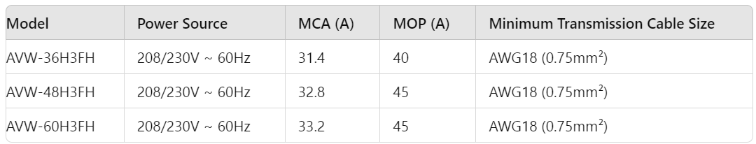

# 

NEWPAGE----------NEWPAGE

# Page : 30

NOTES:

1. Field wiring shall conform to local laws and regulations, and all wiring operations must be performed by qualified professionals.
2. Refer to relevant standards for the power cord size mentioned above.
3. When the power cord is connected through a junction box in series, ensure to calculate the total current and select wires based on Table 6.1.
4. The wiring specifications for weak-current communication circuits shall not be lower than that for Rvv(S)P shielded wires or equivalent, and the shielding layer shall be grounded.
5. Install a switch that ensures all-pole disconnection between the power supply and air conditioning unit, with contact spacing not less than 1/8 inch (3mm).
6. Contact the dealer or professionals from the designated maintenance department promptly for repair and replacement if the power cord is damaged.
7. For power cord installation, ensure the ground wire is longer than the current-carrying conductor. Keep a distance between each wiring terminal and attach insulation tape or sleeve as shown in the figure.

**Wiring Method with Clamp**

* **Correct:**
  + Insert the wires with a cord clamp as shown in the figure.
  + Mount the clamp on the stop valve mounting plate and tighten it with screws.
* **Incorrect:**
  + Do not use a solderless terminal when a single wire is used, as it may cause abnormal heating at the caulking portion of the terminal. If a single wire is used, connect the wire directly as shown in the figure.

**CAUTION:**

* When using conduit, do NOT lead it in the outdoor and refrigerant cycle in the outdoor unit, as it may cause damage to them.

NEWPAGE----------NEWPAGE

# Page : 31

**! CAUTION**

Install a multi-pole main switch with a space of 1/8 in. (3.0mm) or more between each phase.

**Outdoor Unit Dip-Switch Setting**

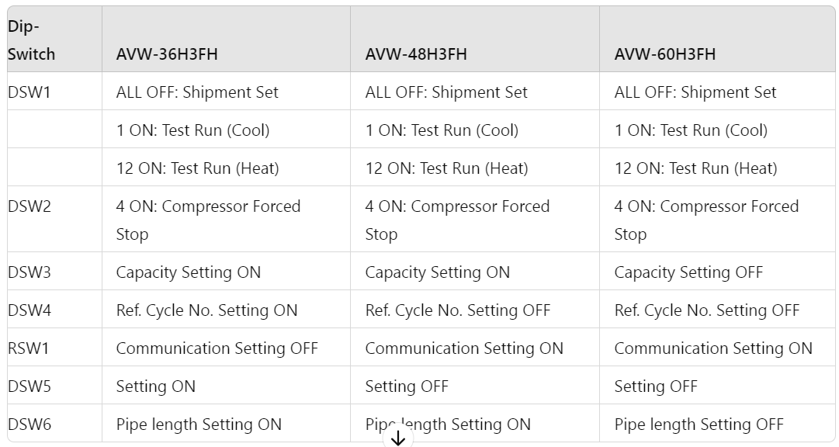

**Notes:**

* **DSW1:** Control settings for test runs and shipment.
* **DSW2:** Control settings for compressor forced stop.
* **DSW3:** Capacity setting for the unit.
* **DSW4:** Setting for refrigerant cycle number.
* **RSW1:** Communication settings.
* **DSW5:** Optional function setting.
* **DSW6:** Setting for pipe length, relative to the unit's position.

# 

# NEWPAGE----------NEWPAGE

# Page : 32

**Terminal Resistor Setting**

Before shipment, ensure the following settings for DSW5:

* Set No.1 pin of DSW5 at the "ON" side.
* If there are multiple outdoor units in the same H-NET (H-NET system No. 1), set No.1 pin of DSW5 at the "OFF" side for the 2nd refrigerant group outdoor unit. No setting is required if only one outdoor unit is used.

**! WARNING**

Do not operate the system until all the check points have been cleared:

* (A) Check and confirm Ref. pipe system and communication wire link to the same Ref. cycle system.
* (B) Check to ensure that the electrical resistance is more than 1 megohm, by measuring the resistance between ground and the terminal of the electrical parts. If not, do not operate the system until the electrical leakage is found and repaired.
* (C) Check to ensure that the stop valves of the outdoor unit are fully opened, and then start the system.
* (D) Check to ensure that the switch on the main power source has been ON for more than 12 hours, to warm the compressor oil by the oil heater.

**Test Run**

Perform the test run according to Table 8.1 on page 26. Use Table 8.2 on page 28 for recording the test run.

**Notes:**

* Pay attention to safety precautions while the system is running, such as avoiding touching hot components and not pushing magnetic switches.
* Wait at least ten minutes after turning OFF the main switch before touching any electrical components.

Operate each indoor unit one by one, checking and confirming their refrigerant cycle and connecting wire joints to the same Ref. cycle system.

# NEWPAGE----------NEWPAGE

# Page : 33

**Table 8.1 Checking of Wire Connection by Test Run**

1. Turn ON the power supply for all the indoor units.
2. For models with the auto-address function:
   * Wait for approximately 3 minutes (up to 5 minutes in some cases) for automatic addressing.
   * Select using the language from the "Menu". Refer to the operation manual for details.
3. Press and hold "Menu" and "+" simultaneously for at least 3 seconds:
   * The test run menu will be displayed.
   * Select "Test Run" and press " ".
   * The test run settings will be displayed.
4. The total number of connected indoor units is indicated on the LCD:
   * For twin combinations (1 set with 2 indoor units), it shows "2".
   * For triple combinations (1 set with 3 indoor units), it shows "3".
   * If the indicated number does not match the actual connected units, check:
     + Power supply for indoor units.
     + Correctness of connecting cables between indoor units or controller cables.
5. Press "Run/Stop":
   * A 2-hour OFF timer will be set automatically.

**Notes:**

* Ensure correct operation of the auto-address function and wiring connections before proceeding with the test run.
* Follow the operation manual for detailed instructions on language selection and menu navigation.

# 

# NEWPAGE----------NEWPAGE

# Page : 34

**Test Run Instructions and Alarm Handling**

1. The temperature detections by the thermistors are invalid though the protection devices are valid during the test run.

**T.RUN MENU Setting:**

* Setting: 3
* Time: 09:36

1. To finish the test run:

* Press "Run/Stop" again or allow the set test run time to elapse.
* To change the test run time:
  + Use "<" or ">" to select "Running Time".
  + Set the test run time (30 to 600 minutes).

**During Test Run Abnormalities:**

* The RUN indicator on the remote control switch flashes if protection devices are activated.
* The RUN indicator (red) on the indoor unit flashes (0.5 second ON / 0.5 second OFF).
* Additional information such as alarm code, unit model code, and number of connected indoor units will be displayed on the LCD.

**Handling Abnormalities:**

* If the RUN indicator on HYXE-J01H flashes:
  + Check for transmission failures between the indoor unit and remote control switch (e.g., loose connector, disconnected or broken wires).
  + Consult authorized service engineers if the abnormality persists and cannot be resolved.

**Notes:**

* Ensure proper operation and monitoring during the test run to detect and address any abnormalities promptly.

# NEWPAGE----------NEWPAGE

# Page : 35

**Table 8.2: Test Run and Maintenance Record**

* **MODEL:**
* **SERIAL. No.:**
* **COMPRESSOR MFG. No.:**
* **CUSTOMER'S NAME AND ADDRESS:**
* **DATE:**

1. Is the rotation direction of the indoor coil fan correct?
2. Is the rotation direction of the outdoor coil fan correct?
3. Are there any abnormal compressor sounds?
   * Has the unit been operated at least twenty (20) minutes?
4. Check Room Temperature:
   * Inlet:
     + No.1 DB: ____________ °F, No. 2 DB: ____________ °F, No.3 DB: ____________ °F, No.4 DB: ____________ °F
     + IWB: ____________ °F, IWB: ____________ °F, IWB: ____________ °F, IWB: ____________ °F
   * Outlet:
     + DB: ____________ °F, WB: ____________ °F
5. Check Outdoor Ambient Temperature:
   * Inlet:
     + DB: ____________ °F, WB: ____________ °F
   * Outlet:
     + DB: ____________ °F, WB: ____________ °F
6. Check Refrigerant Temperature:
   * Liquid Temperature: ____________ °F
   * Discharge Gas Temperature: ____________ °F
7. Check Pressure:
   * Discharge Pressure: ____________ Psi
   * Suction Pressure: ____________ Psi
8. Check Voltage:
   * Rated Voltage: ____________ V
   * Operating Voltage: ____________ V
   * Starting Voltage: ____________ V
9. Check Compressor Input Running Current:
   * Input: ____________ kW
   * Running Current: ____________ A
10. Is the refrigerant charge adequate?
11. Do the operation control devices operate correctly?
12. Do the safety devices operate correctly?
13. Has the unit been checked for refrigerant leakage?
14. Is the unit clean inside and outside?
15. Are all cabinet panels fixed?
16. Are all cabinet panels free from rattles?
17. Is the filter clean?
18. Is the heat exchanger clean?
19. Are the stop valves open?
20. Does the drain water flow smoothly from the drain pipe?

# 

# 

# 

# NEWPAGE----------NEWPAGE

# 

# 

# 

# 

# 

# Page : 36

Table 8.3: Alarm Code

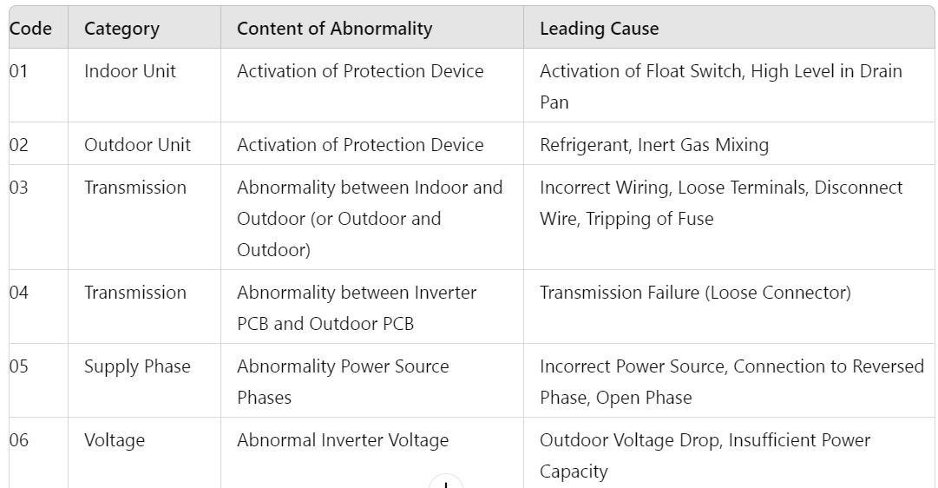

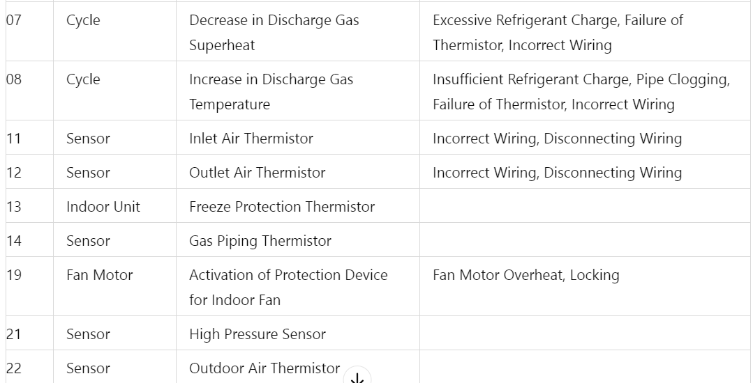

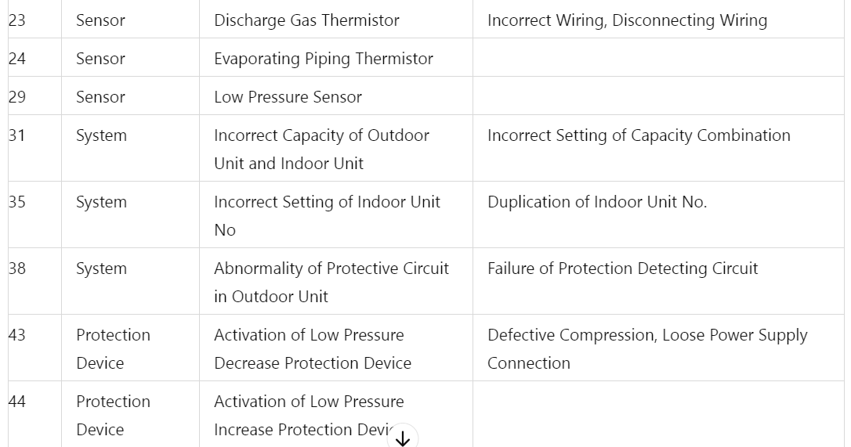

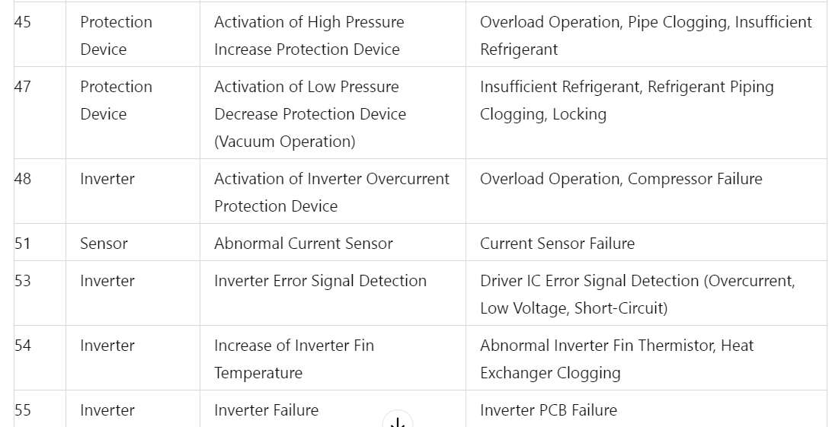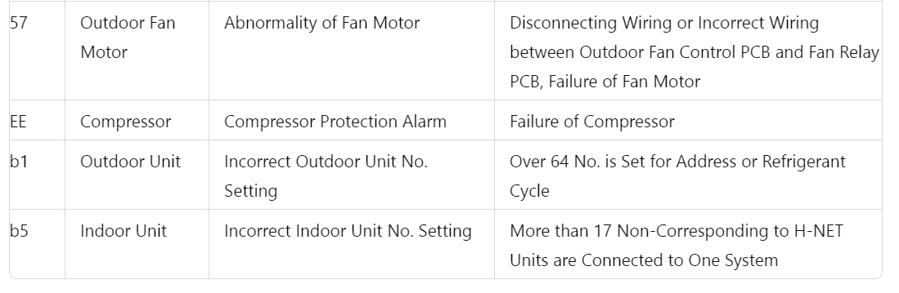

NEWPAGE----------NEWPAGE

# Page : 37

**Safety and Control Device Setting**

* **Compressor Protection**
  + **High Pressure Switch:**
    - Model: AVW-36/48/60H3FH
    - Pressure Switch Type: Automatic Reset, Non-Adjustable
    - **Cut-Out Pressure:** 601 psi (4.15 MPa)
    - **Cut-In Pressure:** 464 psi (3.2 MPa + 0.10)
* **Fuse on Main Circuit**
  + **Rating:** 50 A
* **Compressor**
  + **Crank Heater Power**
    - Rating: 60 W
    - **Minimum Time:** 3 min
* **CCP Timer Set Time**
  + Setting: 30 min
* **Control Circuit Fuse**
  + **Rating:** 5 A

NEWPAGE----------NEWPAGE

# Page : 40

**Company Information:**

* **Company Name:** Qingdao Hisense Hitachi Air-conditioning Systems Co., Ltd.
* **Address:** No.218, Qianwangang Road, Economic and Technological Development Zone, Qingdao, China
* **Website:** [www.hisensehvac.com](http://www.hisensehvac.com)
* **Email:** export@hisensehitachi.com

**Disclaimer:**

* The Company is committed to continuous product improvement. We reserve the right to alter the product information at any time and without prior announcement.

**Document Identification:**

* **Document Code:** M00376Q04.2022V04

NEWPAGE----------NEWPAGE